**Clonezilla - Cloning and Restoration Disk Image Using Virtual Box**

**A.1) Cloning Section Using USB**

1. First, we need to make the USB bootable so that it can be boot during the BIOS system operate. In this case, we use Rufus software, here is the download link for the application <https://rufus-usb.en.uptodown.com/windows/download>.
2. 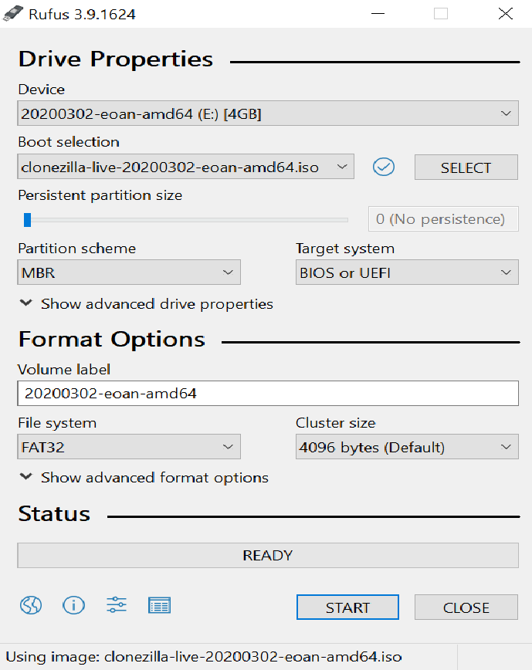Run the Rufus application, select the disk that you want to use and make sure clonezilla.iso is the targeted file to boot. Finally, click ‘Start’ to start the process.

Diagram 2.1

1. Now the USB was ready to be bootable into BIOS system. We need to install external software to make the USB bootable in VirtualBox. Here is the link for the software named Virtual Machine USB Boot: <http://reboot.pro/files/download/339-virtual-machine-usb-boot/>, make sure to select the ‘**portable version**’. If you are using VirtualBox version 6 and above, you need to downgrade to version 5 because it will get some issues with the software to running. In this case, we are using VirtualBox 5.2.18 as well with the extension pack. Here is the download link: <https://download.virtualbox.org/virtualbox/5.2.18/>.
2. 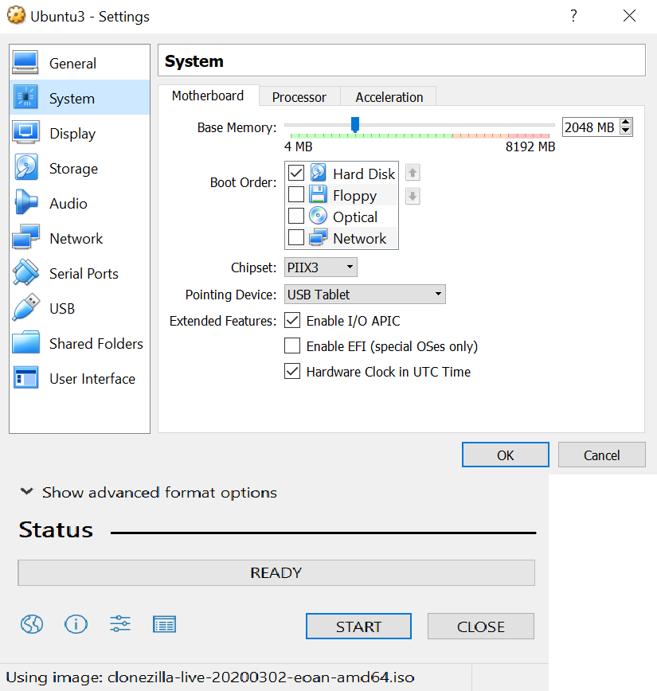At the VirtualBox Motherboard setting, just enable hard disk because we want it to boot only from USB.

Diagram 4.1

* 1. While at Acceleration, tick both boxes.

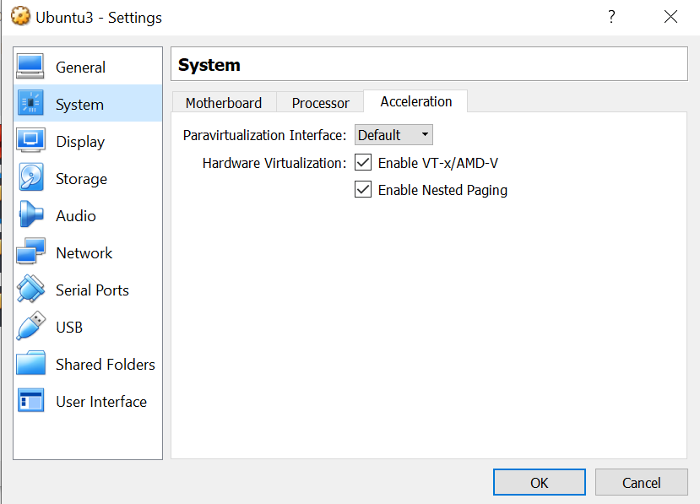

Diagram 4.2

* 1. 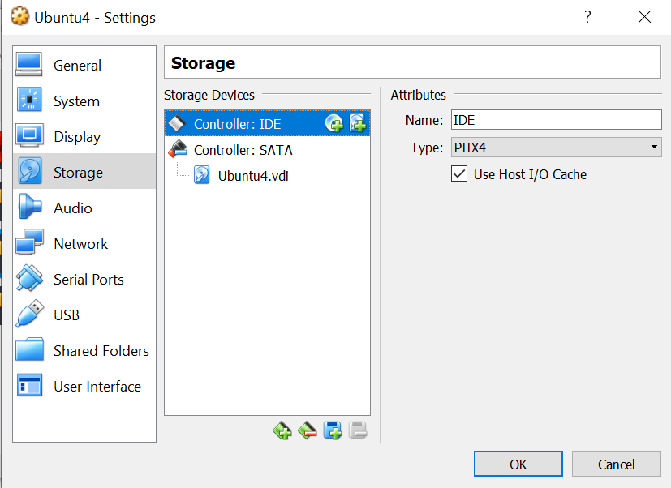Select IDE Controller and Delete it with the green disk with minus icon

Diagram 4.3

* 1. Download the extension pack based on your VB edition, here is the link <https://download.virtualbox.org/virtualbox/5.2.18/> , choose the link that shown by red arrow

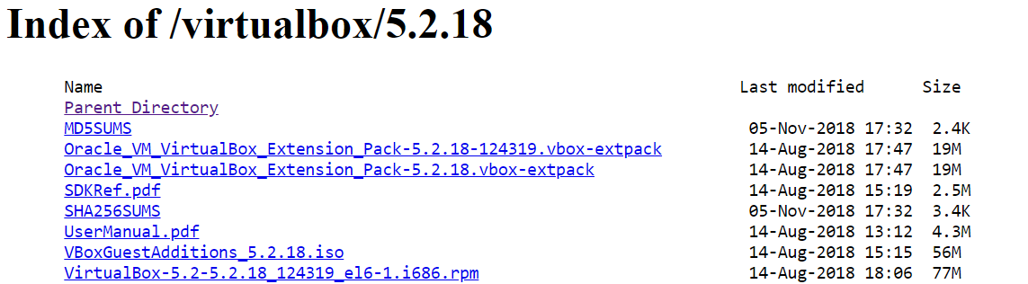

Diagram 4.4

* 1. Mount the USB that you want to put the cloning so that system recognized it
  2. From VB Setting, Click USB -> USB with green plus image to add the USB

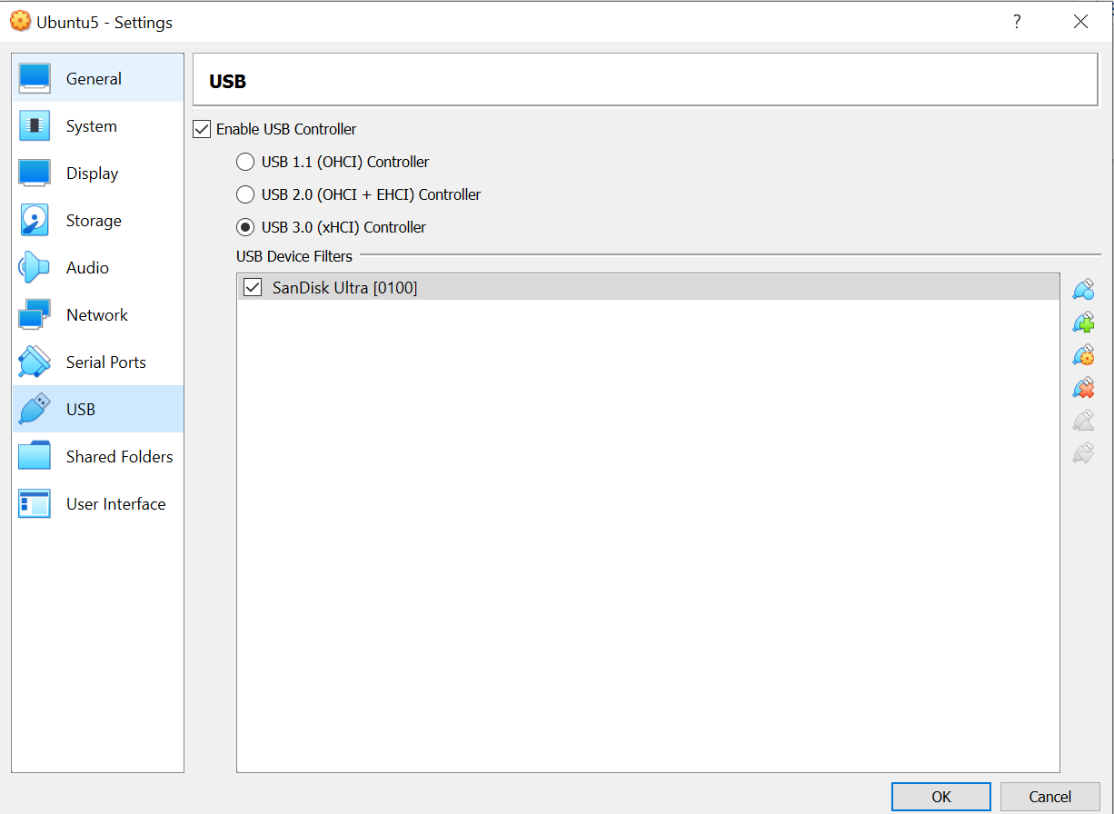

Diagram 3.3

1. 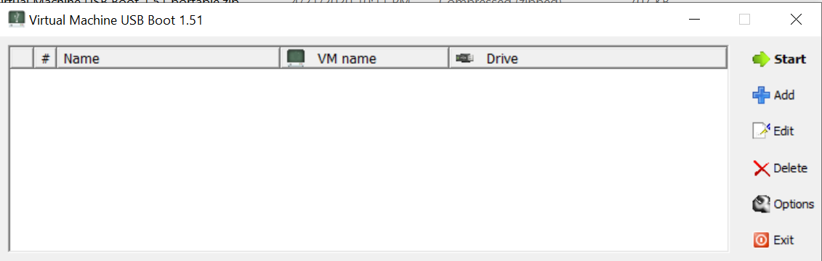Run the Virtual Machine USB Boot application. Click at ‘Options’ box, then click at click enable Vtx

Diagram 5.1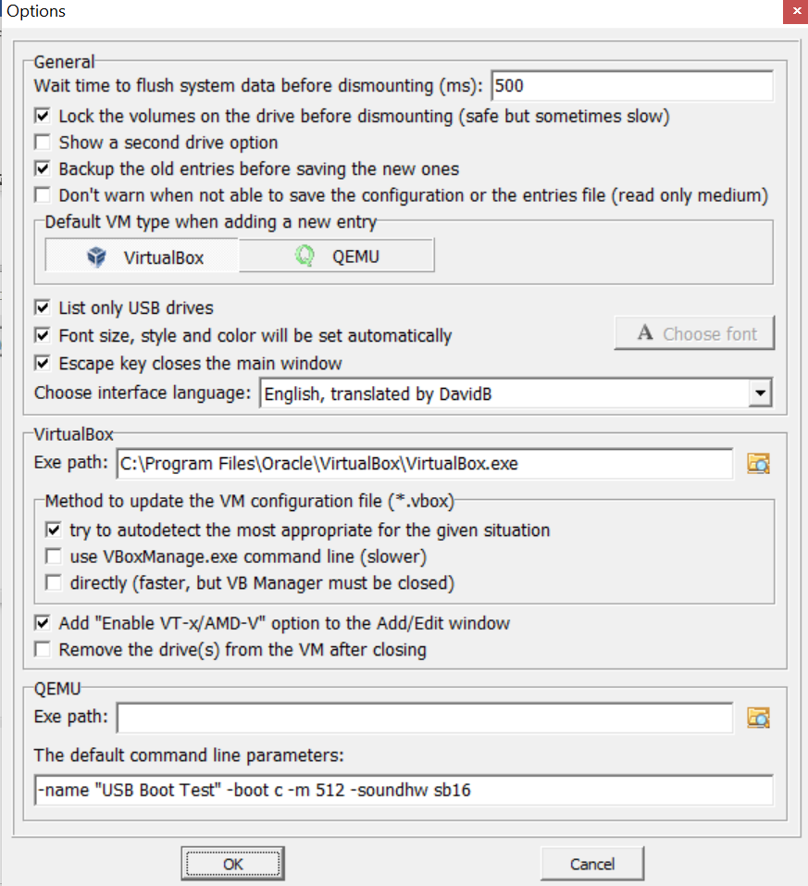

Diagram 5.2

5.1 Click ‘Add’ -> name the Boot Test -> select VM name -> drive to add -> select ‘on’ for enable VT-x/AMD-V -> click ok

Diagram 5.3

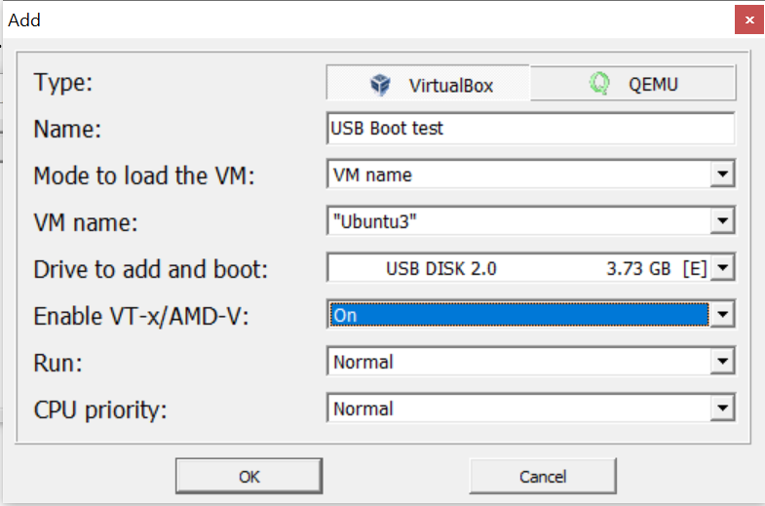

Diagram 5.4

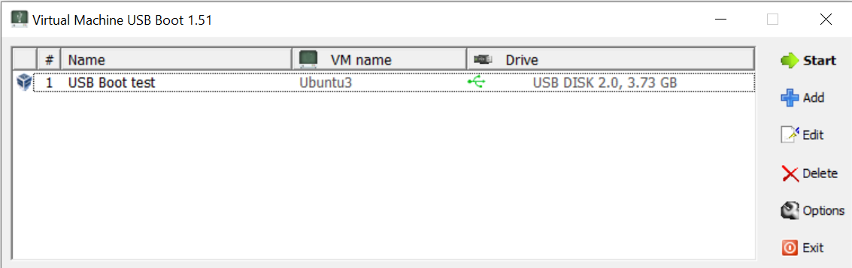

Diagram 5.5

1. If you face problem like ‘Failed: system halt’, you need to delete the extension pack file inside the VirtualBox file and install it again. Maybe it got problem during installation of extension pack

**A.2) Cloning Section Using CD/DVD**

1. 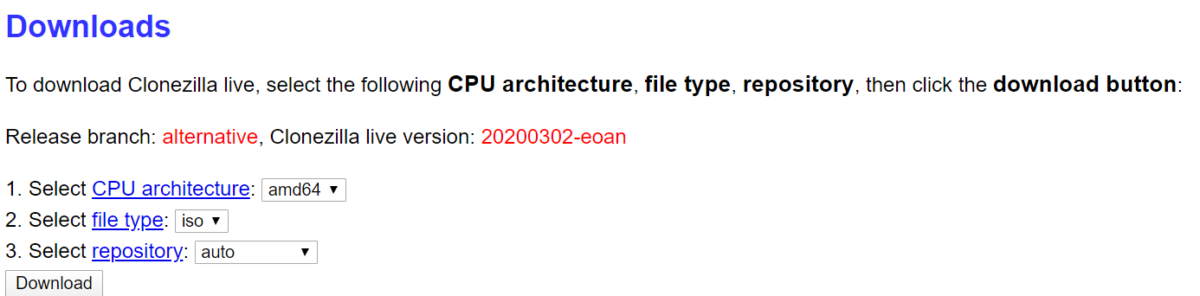Download the stable Clonezilla, make sure to change the file into “.iso” so that it can boot from CD. Here is the link: <https://clonezilla.org/downloads/download.php?branch=alternative> for the alternate stable Clonezilla.

Diagram 1.1

1. To enable VirtualBox (VB) to booting from the CD/DVD:
   1. 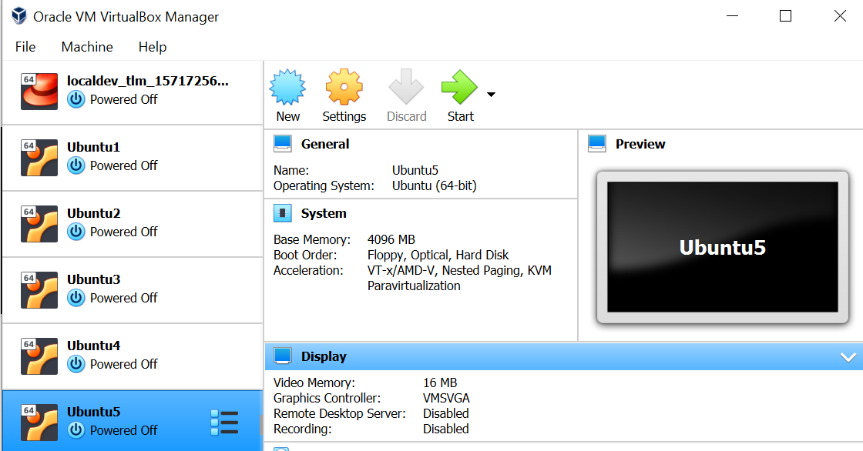open your Virtual Box and click on Setting

Diagram 2.1

2.2 then click at Storage -> empty disk -> choose disk file that contain clonezilla .iso format

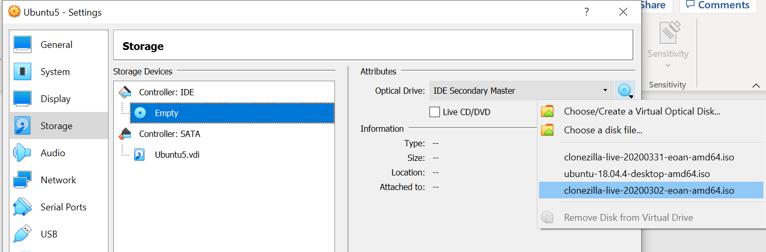Diagram 3.1

1. Then enable USB into the VB to store the cloning image:
   1. Make sure to update your VB first before making any changes to keep the software updated
   2. 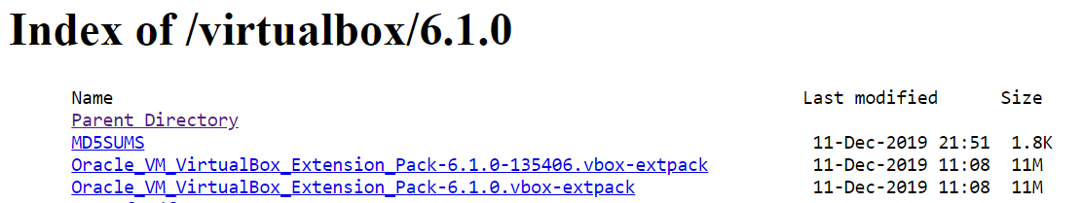Download the extension pack based on your VB edition, here is the link <https://download.virtualbox.org/virtualbox/6.1.0/> , choose the link that shown by red arrow

Diagram 3.2

* 1. Mount the USB that you want to put the cloning so that system recognized it
  2. From VB Setting, Click USB -> USB with green plus image to add the USB



Diagram 3.3

1. Begin the cloning step
   1. A close up of a map

      Description automatically generatedThis is the main page of Clonezilla after system booting into CD, select the first choice (default setting, VGA 800x600)

Diagram 4.1

* 1. Then choose language

Diagram 4.2

* 1. 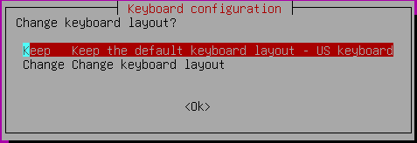Select ‘Keep the default keyboard layout’ at the first choice

Diagram 4.3

* 1. Choose to Start Clonezilla.

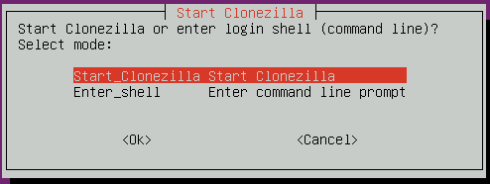

Diagram 4.4

* 1. 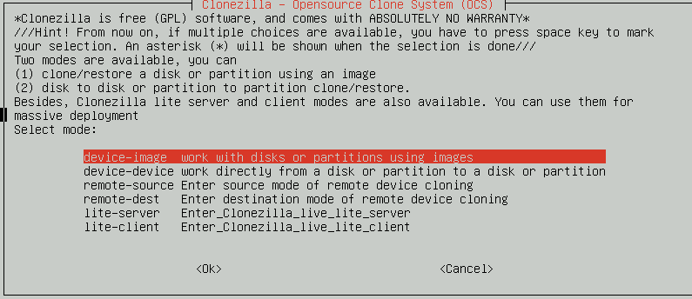In this case, we are going to clone the disk image and restore it to another OS, so choose first choice ‘device-image’.

Diagram 4.5

* 1. 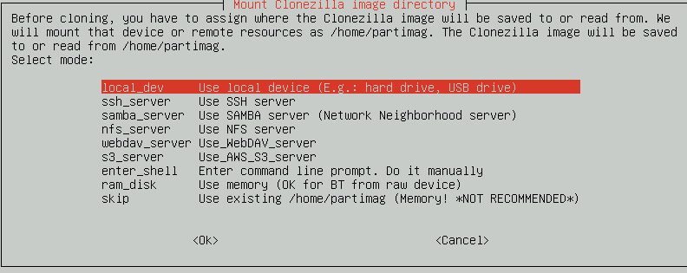Select ‘local_dev’ option because we want to store the image into external USB or hard drive

Diagram 4.6

* 1. 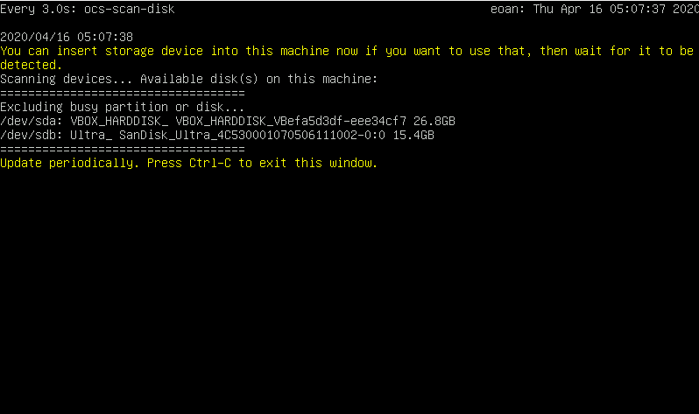During this process, mount the external USB/HDD that you want to use. Wait for a while for the system to detect your USB/HDD. In this case the external USB has been use and it will show up in the list. After that, Press Ctrl-C to exit the window.

Diagram 4.7

* 1. 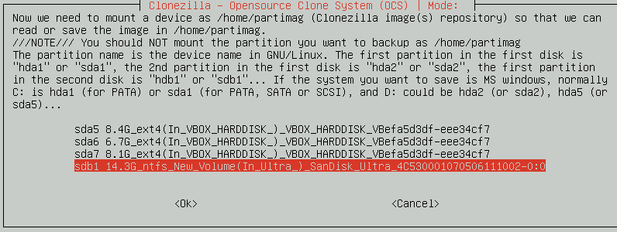In this case, choose the USB/HDD that you mount which the place to store the image.

Diagram 4.8

* 1. 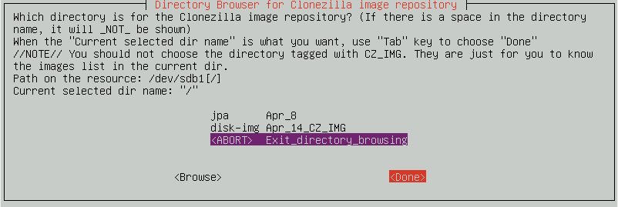In this selection, select ‘<ABORT> Exit_directory_browsing’ to store the image outside without entering any files as default.

Diagram 4.9

* 1. 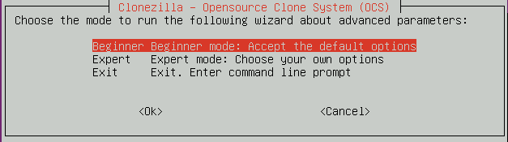Select the ‘Beginner mode’

Diagram 4.10

* 1. 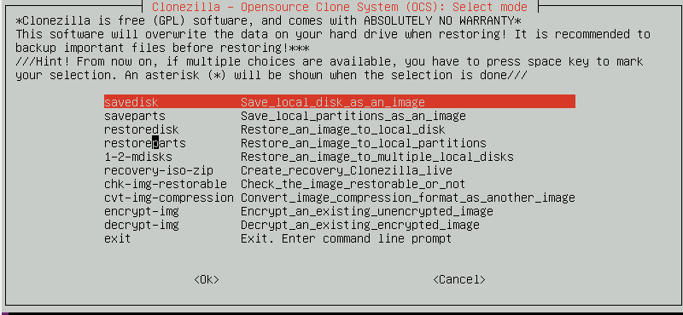Select the ‘savedisk’ option as we want to clone the whole disk as an image. You can choose to clone by partition unless the new OS got the partition already, if not the restoration process will fail as Clonezilla cannot detect the new partition. The better way is to clone the whole disk to prevent any circumstances

Diagram 4.11

* 1. 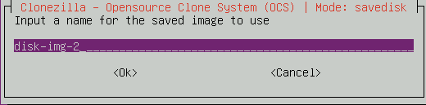In this window, name the file that store the disk image. It will show up after the cloning process done inside the USB/HDD

Diagram 4.12

* 1. 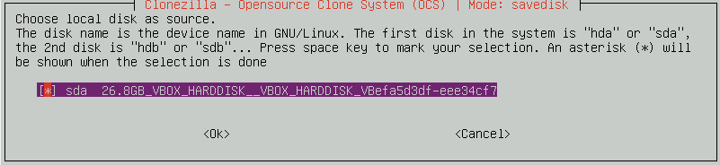Select the disk that you want to clone, press ‘space’ at the checkbox list then press enter

Diagram 4.13

* 1. 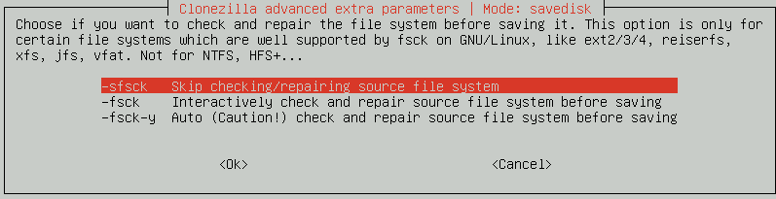In this case, just select ‘Skip checking/repairing source file system’ to speed up the process. You also can select ‘Interactively check and repair source file system before saving’ if you want Clonezilla to check the file system but it will take sometimes to process.

Diagram 4.14

* 1. 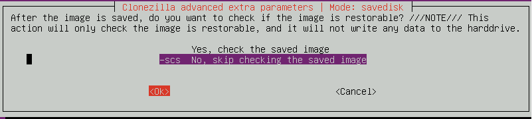This process same goes as 4.14 either you want to check the image or not. To speed the process just select ‘No, skip checking the saved image’.

Diagram 4.15

* 1. 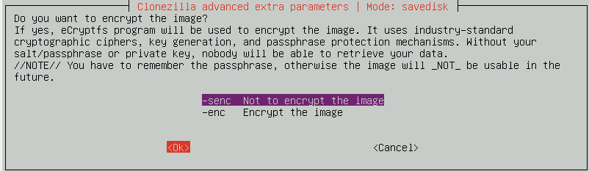This process same goes as 4.14 and 4.15 either you want to encrypt the image or not. To speed the process just select ‘Not to encrypt image’. Then press enter.

Diagram 4.16

* 1. 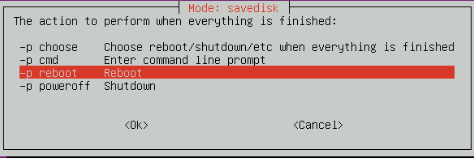In this case, you can select to reboot, power off, enter cmd, and choose by yourselves on what to do after the cloning process end. It is better to choose reboot so that you know the image of the disk already store inside the USB/HDD or not. Then press enter.

Diagram 4.17

* 1. 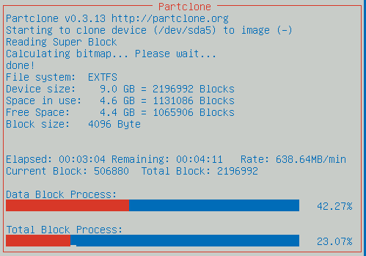This show up the cloning process is undergoing. Just leave the process until it done

Diagram 4.18

* 1. 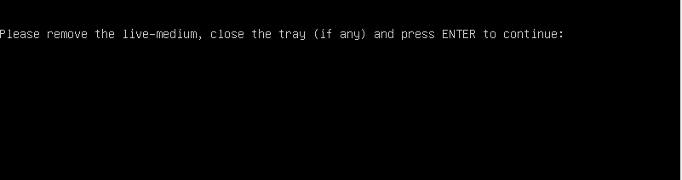In this window, just follow the instruction with pressing enter. After this window, the system will reboot as was choose by you

Diagram 4.19

* 1. 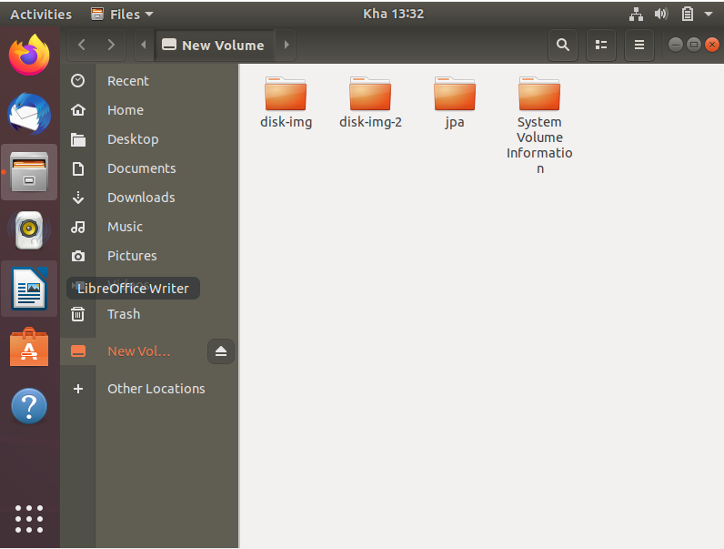After reboot the OS, click at the external USB/HDD to see whether it was there or not. The name was stated as named by user. Diagram 22 show the file that contain disk image while Diagram 23 show the content of the image inside the file

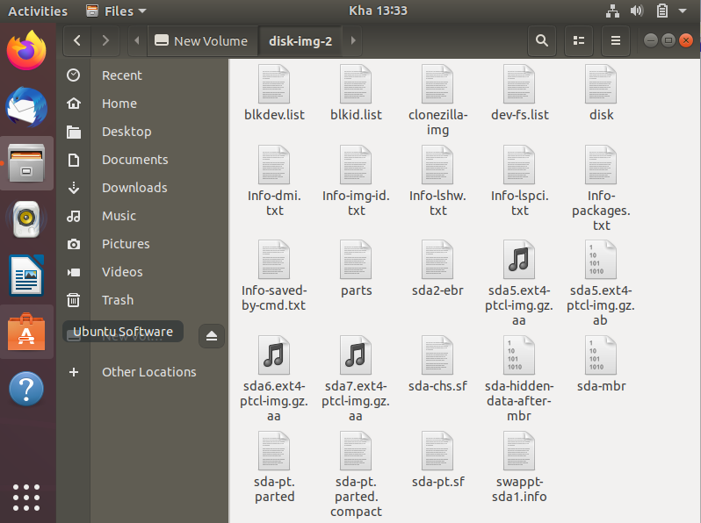Diagram 4.20

Diagram 4.21

**B) Restoring Part**

1. First, create a new OS without any installation.
   1. 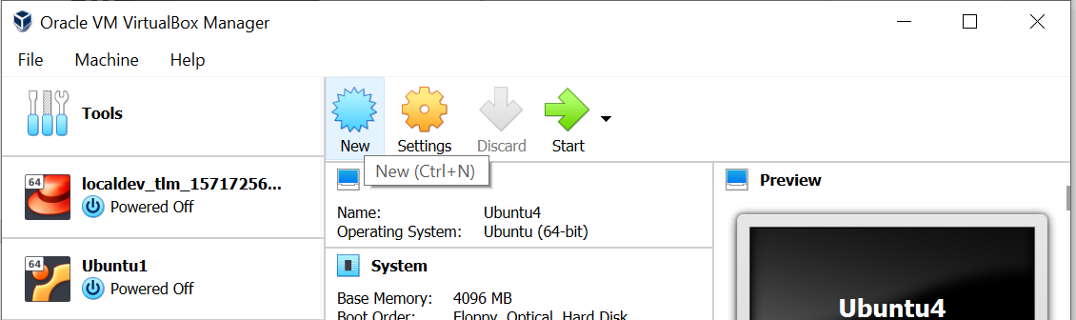Click New to create new OS

Diagram 1.1

* 1. 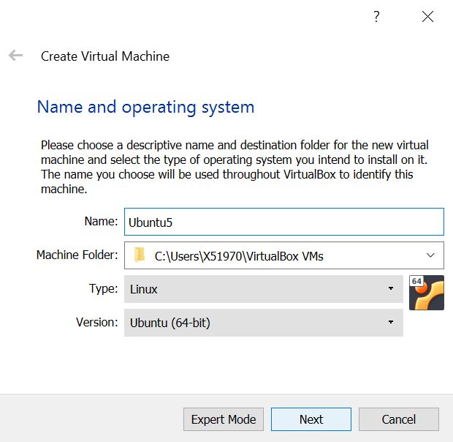Name the new OS, then click Next

Diagram 1.2

* 1. 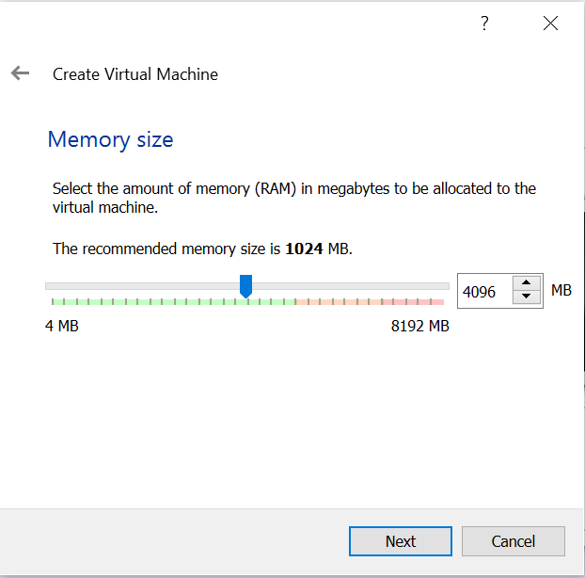Determine the size of the virtual OS RAM

Diagram 1.3

* 1. 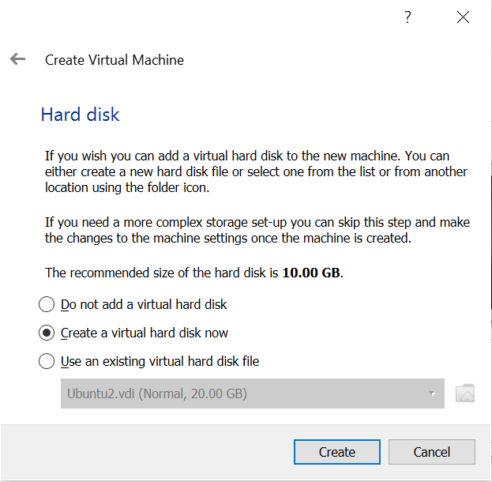Select ‘Create an existing virtual hard disk file’

Diagram 1.4

* 1. 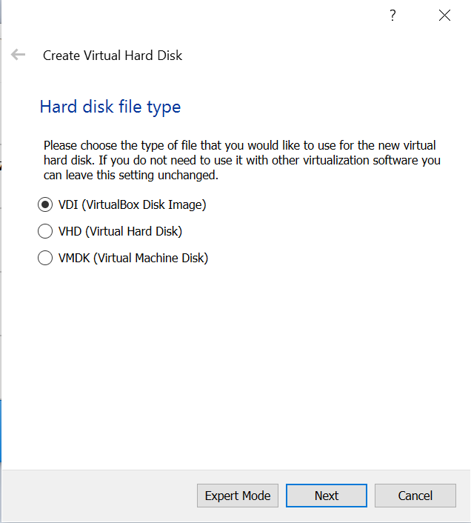Select VDI

Diagram 1.5

* 1. 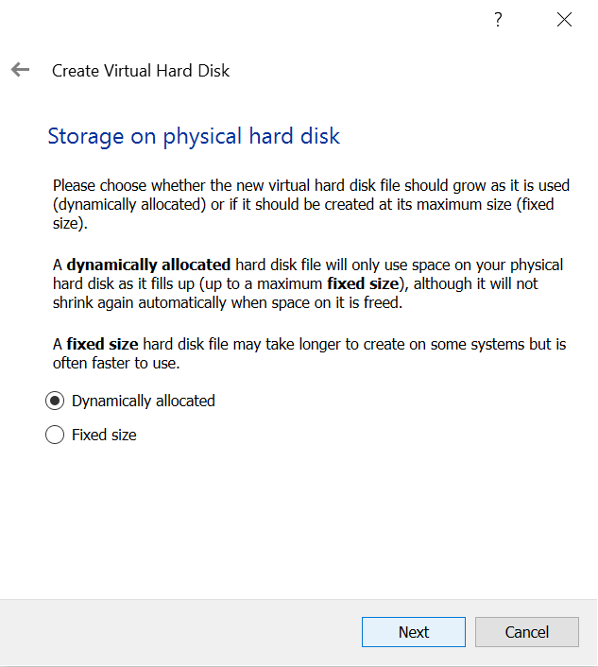Next select ‘Dynamically allocated’

Diagram 1.6

* 1. 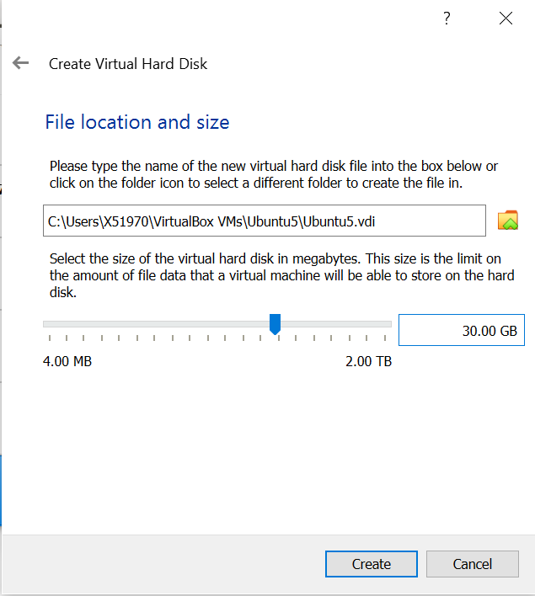Select the size of the new OS, make sure it is equal or more than the size of the size cloning disk image, if not the cloning process will be failed.

Diagram 1.7

1. Start the restoration process
   1. Enable the USB/HDD from Setting and select the Clonezilla.iso for the CD as stated from the above in section A.2.2 and A.3.4. before starts the OS



Diagram 2.1



Diagram 2.2

* 1. 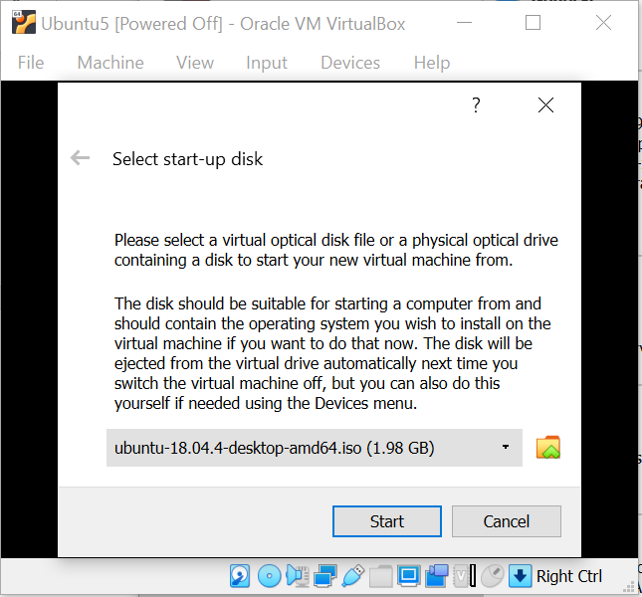When this window shown up, select ‘Cancel’ because we want to restore the disk image into new OS without installation. All the partition and system will be exactly like the old OS after restoration process. Thus, no need to do the installation process.

Diagram 2.3

* 1. 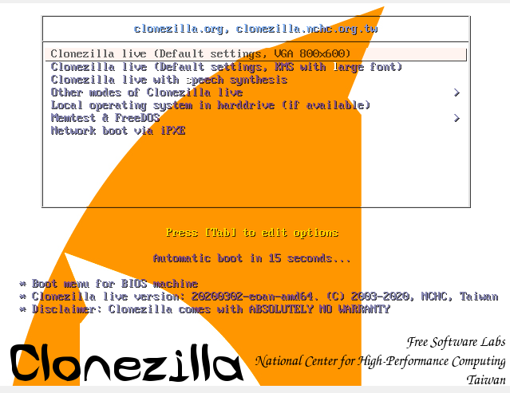The main page of Clonezilla as usual, select the first one

Diagram 2.4

* 1. 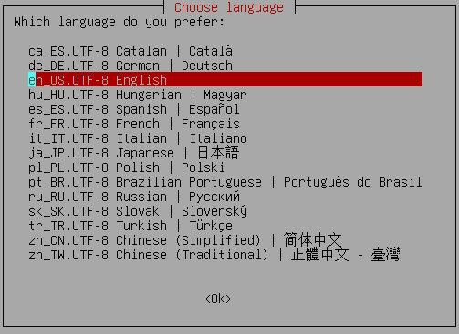Select the language

Diagram 2.5

* 1. Select ‘Keep the default keyboard layout’. No need to change

Diagram 2.6

* 1. Choose to ‘Start Clonezilla’

Diagram 2.7

* 1. As usual for the restoration process, select ‘device-image’ as we want to restore the disk using image



Diagram 2.8

* 1. Select ‘local_dev’ as we restore it from USB/HDD



Diagram 2.9

* 1. Mount the USB/HDD that contain the image of disk, wait for a while so that the system detects the device.



Diagram 2.10

* 1. 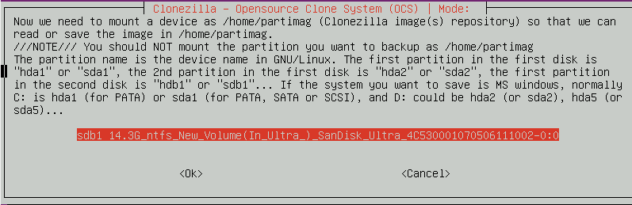Select the USB/HDD that has been mount, if got more than one USB/HDD that you have mount, make sure to select the right one

Diagram 2.11

* 1. Select the file that contain disk image, in this case ‘disk-img-2’ has been choose

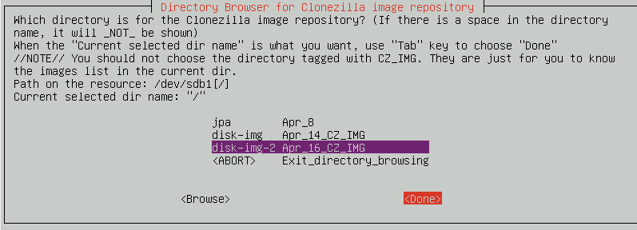

Diagram 2.12

* 1. 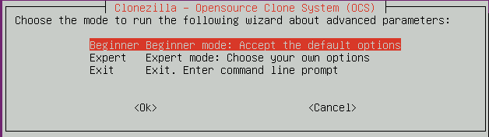Select ‘Beginner’ mode as well as the cloning process. You may face difficulty in restoring if choosing ‘Expert’ mode.

Diagram 2.13

* 1. In this section, select ‘restoredisk’ as we want to restore image of the whole disk

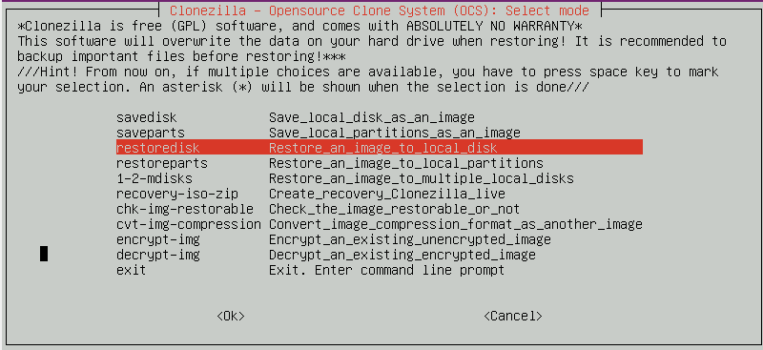

Diagram 2.14

* 1. 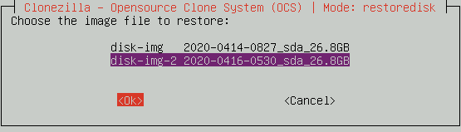Then, select the name of the disk image

Diagram 2.15

* 1. Select the targeted disk that you want to restore the disk image from the new OS

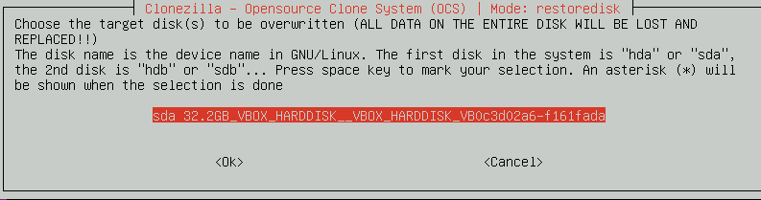

Diagram 2.16

* 1. Select to skip the checking of the image to speed up the process

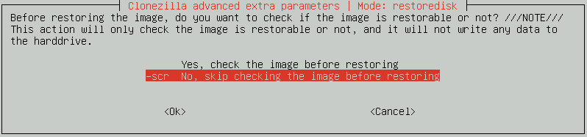

Diagram 2.17

* 1. 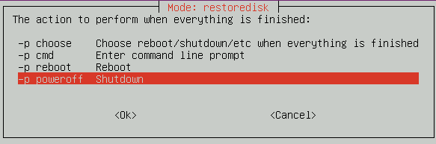In this section, select ‘poweroff’ option to avoid any circumstance.

Diagram 2.18

* 1. When the system asking either you want to continue or not twice, just press ‘y’ and enter

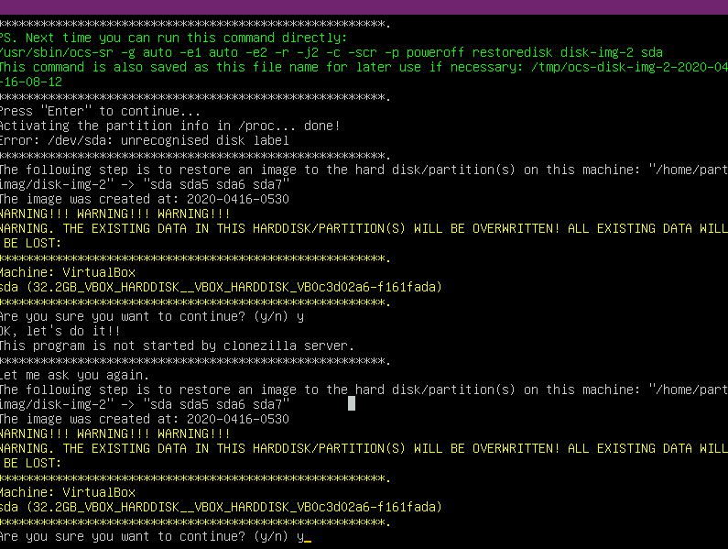

Diagram 2.19

* 1. 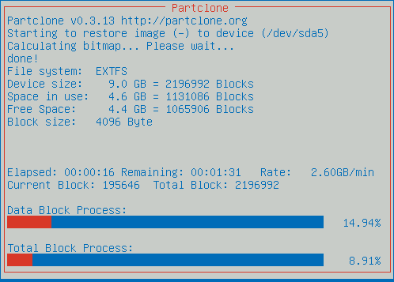After that, it will show up the cloning process, just leave it until the process end. Then it will power off as choose by user

Diagram 2.20

* 1. Now you can Start the new targeted OS after it is shutting down.

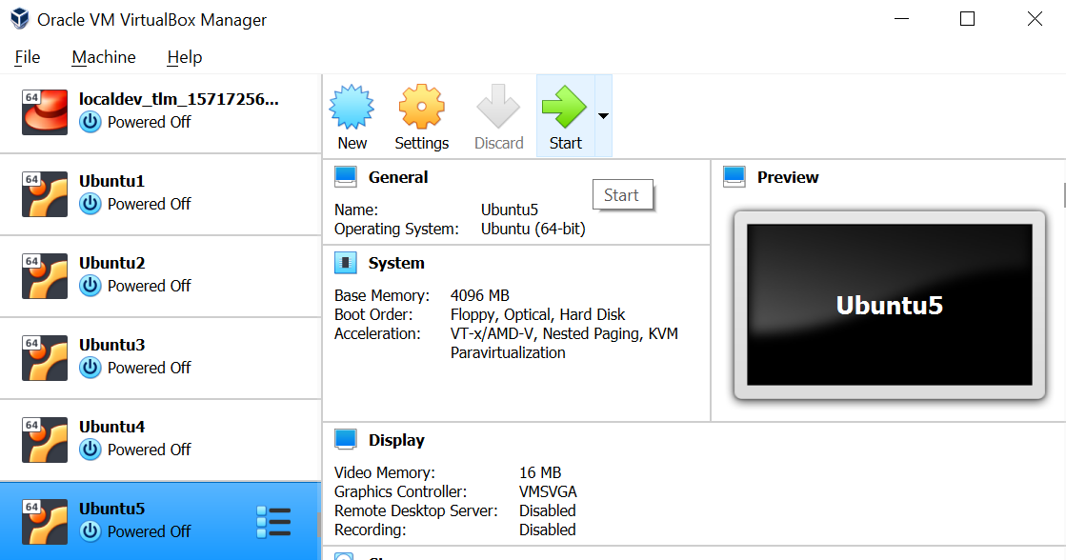

Diagram 2.21

* 1. 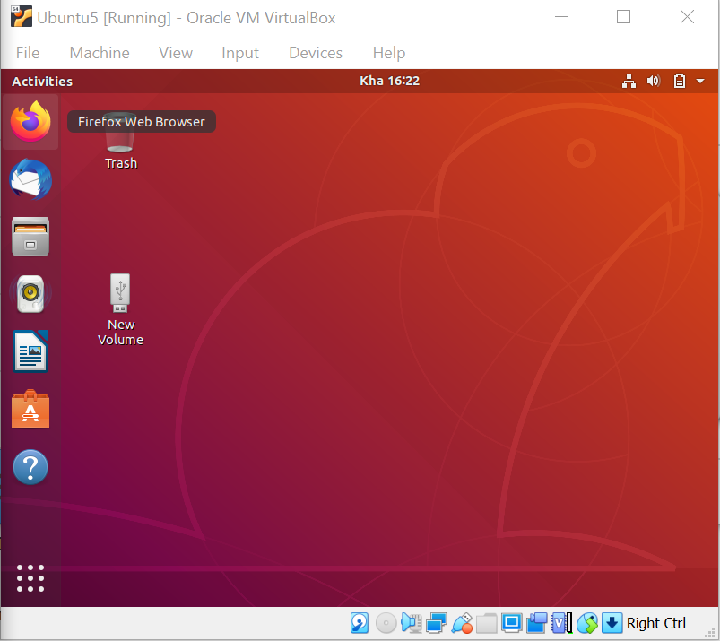All set, the process was done properly, Diagram 2.22 show the new OS was set as well as the old OS while Diagram 2.23 and Diagram 2.24 show the amount of the new OS partition equal as old OS partition but Diagram 2.23 has additional 5.4GB as the OS was created with bigger storage.

Diagram 2.22

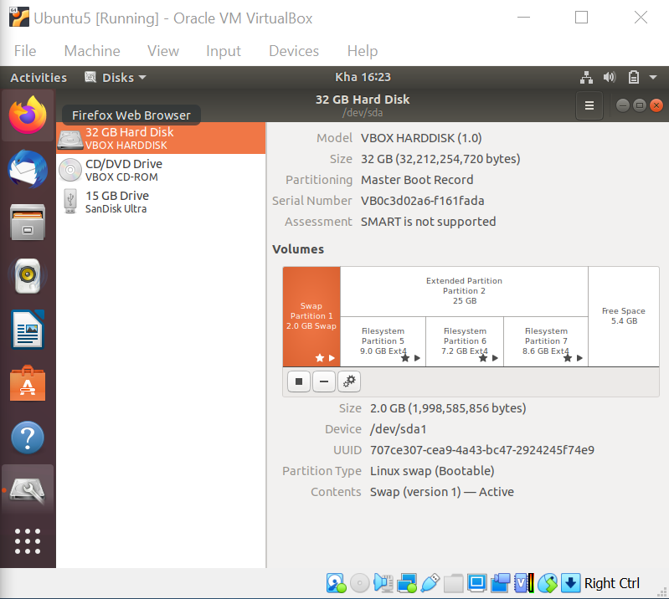

Diagram 2.23

Diagram 2.24

**Setting Local Server(Xen Server)**

1. Setting up the local server
2. Make sure the system recognized all the VD (Virtual Drive), it will show ‘Online’ indicator when the VD are recognized and functioning

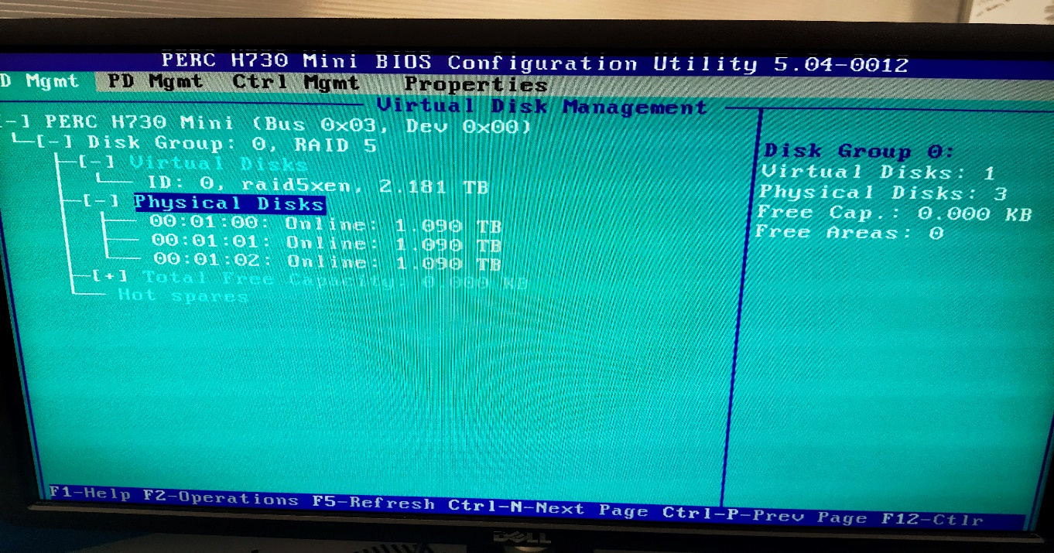

Diagram 1.0

1. 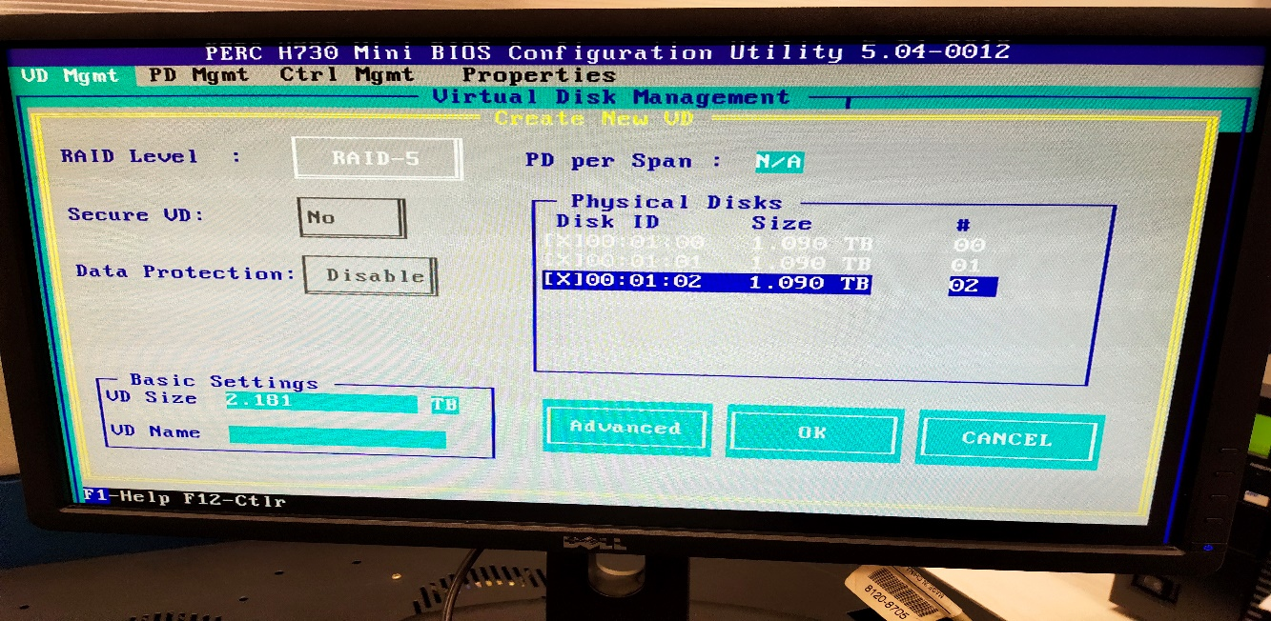Set all the disk to RAID 5

Diagram 1.1

1. If the system cannot recognize the VD, make sure the RAID 5 driver are compatible with the system
2. Press F2 at the VD (Virtual Disk), select Initialization for the system recognized the hardisk

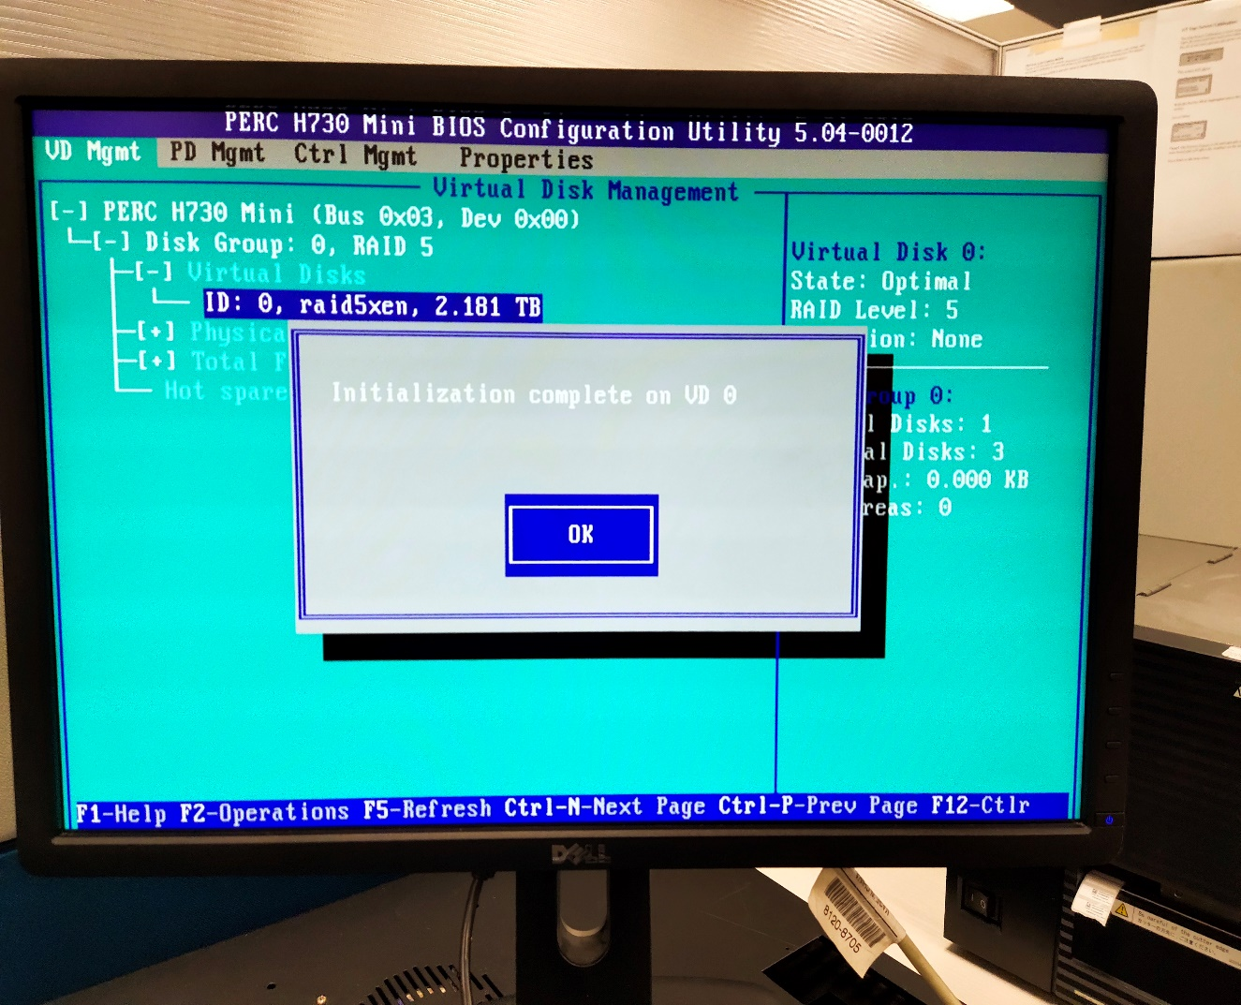

Diagram 1.2

1. Then proceed to install Xenserver, make sure system recognized the USB/hardisk/CD that contain the installer of Xenserver
2. Do the Cloning using Clonezilla
3. Enter BIOS setting
4. Enable booting from USB and make it as priority
5. Follow all the cloning steps starting from **A.4**
6. Before doing restoration, do Initialization(format)
7. Do initialization via system setting
8. During black screen, press Ctrl + r to enter system setting
9. Press F2 at the VD (Virtual Disk), select Initialization to format the hardisk back to default
10. After reboot/shut down system
11. Enter BOOT menu
12. Select ONE-SHOT selection
13. Then choose USB/hardisk that have Clonezilla
14. Do the Restoration by using the image created before
15. Enter BIOS system
16. Make sure the hardisk that contain image has been detected by the system
17. Follow all the restoration steps starting from **B.2.3**